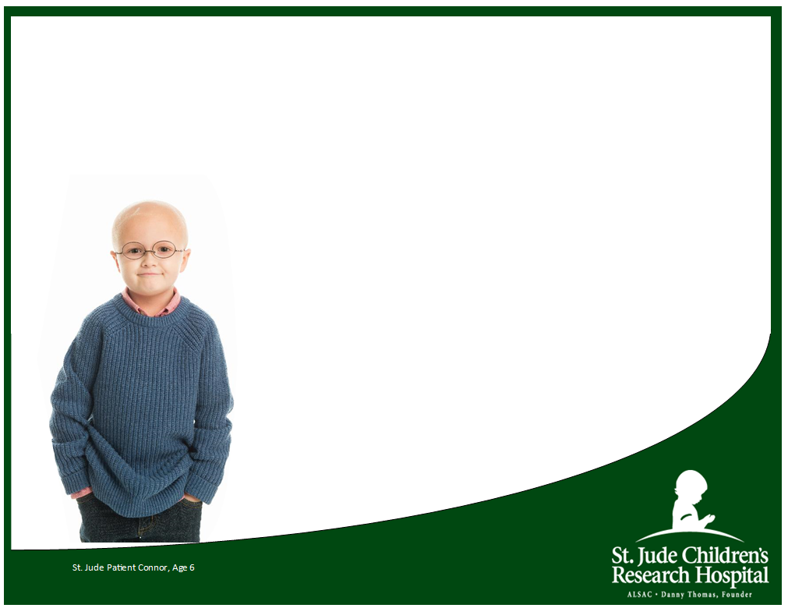

**12th Annual**



Monday, October 3, 2022 Shotgun Start 10:00 AM AMAMAM  
Arrowhead Country Club

**Golf Outing**

**DTS Charities**

PRESENTED BY DESIGN & TECHNICAL SERVICES

**REGISTRATION FORM**

***TEAM NAME***

Full Team Registration = 4 @ $100 . . . . . . . . . . . . . . .  **$400**

***Golfer # 1 name:*** [ ] $100

E-mail

Phone

***Golfer # 2 name:*** [ ] $100

E-mail

Phone

***Golfer # 3 name:*** [ ] $100

E-mail

Phone

***Golfer # 4 name:*** [ ] $100

E-mail

Phone

* ***GOLD Corporate Sponsor . . . . . . . . . . . . . . . . . . . . . . .*** $5000  *Includes: 3 teams, 4 large signs, company table,*

*logo in golfer gift bag, corporate sponsor recognition,*

*name on event banner*

* ***SILVER Corporate Sponsor . . . . . . . . . . . . . . . . . . . . . .*** $3000  *Includes: 2 teams, 2 large signs, corporate sponsor recognition, name on event banner*
* ***BRONZE Corporate Sponsor . . . . . . . . . . . . . . . . . . . . .*** $1500  *Includes: 1 team,1 Hole sign, corporate sponsor*

*recognition, name on event banner*

* ***FRIENDS of ST. JUDE . . . . . . . . . . . . . . . . . . . . . . . . . . . .*** $500  *Includes: 1 player + name on the Friends of St Jude sign*
* ***Hole Sponsor . . . . . . . . . . . . . . . . . . . . . . . . . . . . . . . . .*** $250  *Includes: 1 Hole sign - provide print-ready graphic/text*
* ***Single Golfer*** *[to be assigned to a team ]* ***. . . . . . . . . .*** $100
* ***I am unable to attend*** *but would like to make*

*a donation to the children of St. Jude* ***. . . . . . . . . . . .*** $ __

**Monday, October 3, 2022  
Registration begins at 8:30 AM  
Shotgun Start at 10:00 AM**

**Please join *Design & Technical Services***

**& St. Jude Ridesin supporting the St. Jude**

**Children’s Research Hospital.**

Over the past ten years, DTS has had the privilege of raising thousands of dollars for cancer research. **Thank you** to the generous people who have supported our effort. With your contributions to our 2022 event, we look forward to another year helping the children of St. Jude!

**Lunch will be provided while you golf!!**



$100 registration for individual player

$400 registration for team

Sponsor packages $250-$5000

**Arrowhead Country Club**

19430 N Centerville Rd

Edelstein, IL 61526

309-7274-4675

arrowhead309.com/golf

**Questions?**

Contact Marcy Gorsuch

309-495-2095  
[MStambaugh@designtechnical.com](mailto:MStambaugh@designtechnical.com)

**REGISTRATION DEADLINE: Oct 3, 2022**

Send completed **REGISTRATION form** **& donation** to:

Marcy Gorsuch

Design & Technical Services

401 SW Water Street, Suite 405

Peoria, IL 61602

**Make checks payable to *DTS Charities***