Caterpillar Foundation Matching Gifts Program Process – St. Jude Rides

- Visit www.caterpillar.com/matching-gifts and click on “Visit Website” under “Caterpillar Participants: Search/Request a Match”
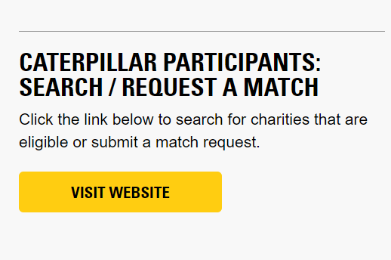

- Register as a first-time user OR login as an existing user. Use your 7-digit HR ID (formerly known as PeopleSoft ID - found in CLUES). Make sure that you include the leading “0” at the beginning of your ID (0_ _ _ _ _ _) so that it is 7 digits total. If you do not know your ID, email Matching_Gifts@cat.com.
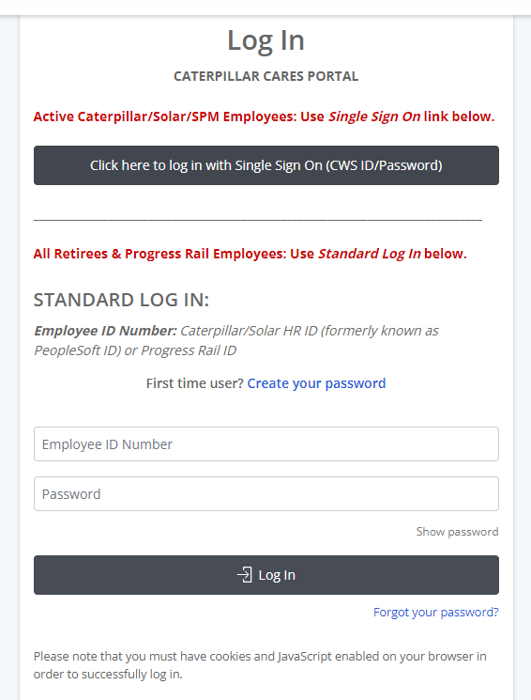

- Click “I ACCEPT” to the matching gifts terms and conditions.
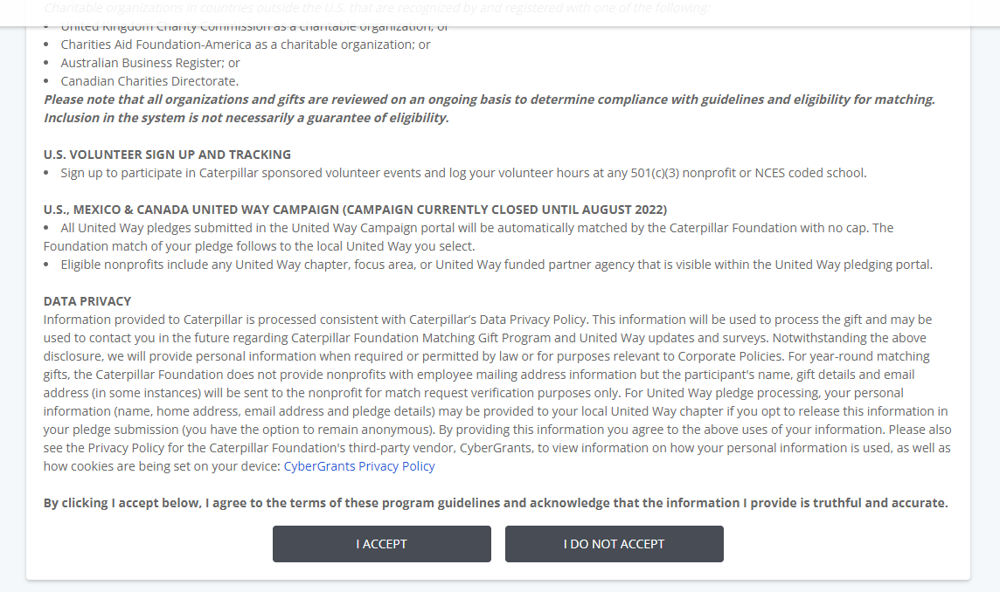

- From the home page, click “Submit a Match Request or Search for Eligible Charities”.

- In the Matching Gifts Nonprofit Search, type in “St Jude Riders” and click “Search”.
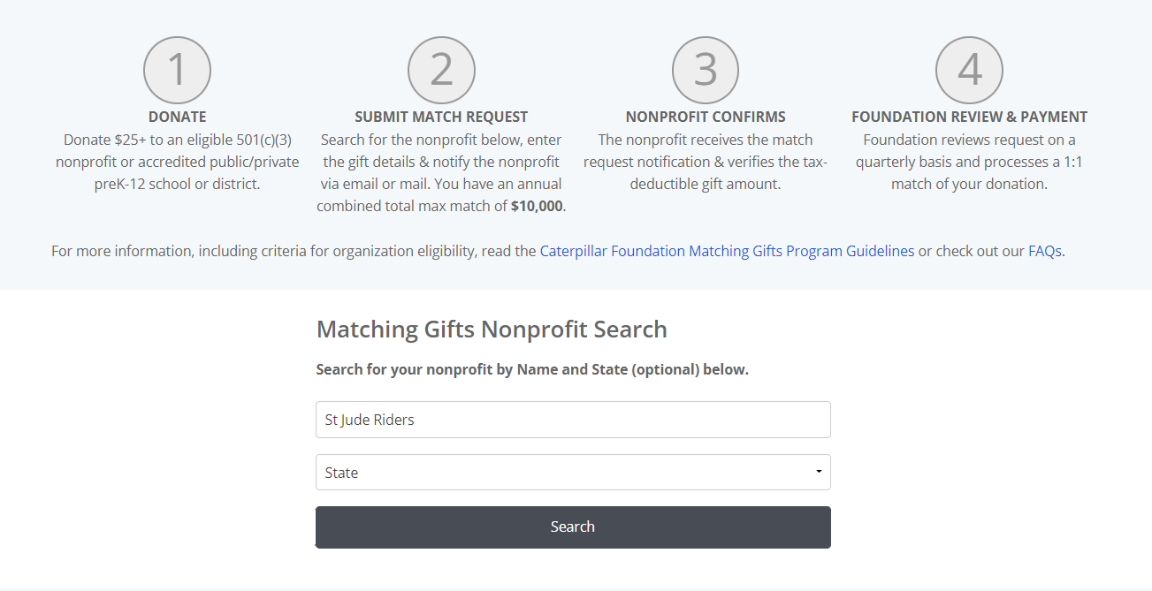

- Click on “Select” next to “St Jude Riders Association NFP”.
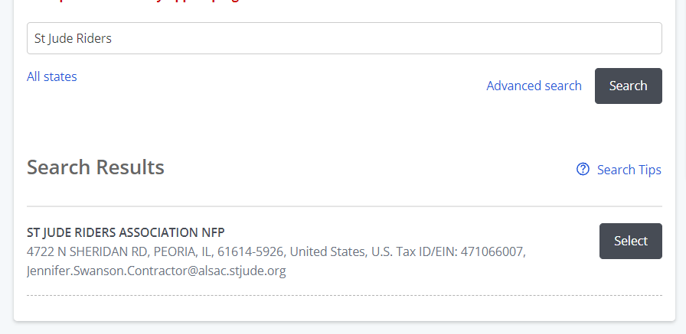

- Enter gift details. If you would like a specific Rider to get credit for this matching gift, type the Rider’s Name and the Satellite City of the Ride they participate in (if known), in the “Designation” field. Click “Save and Proceed”.
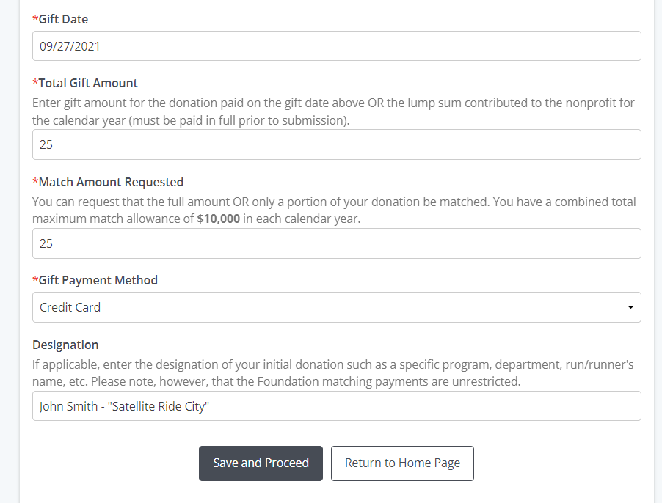

- Review, update (if necessary), and then click “Submit”.
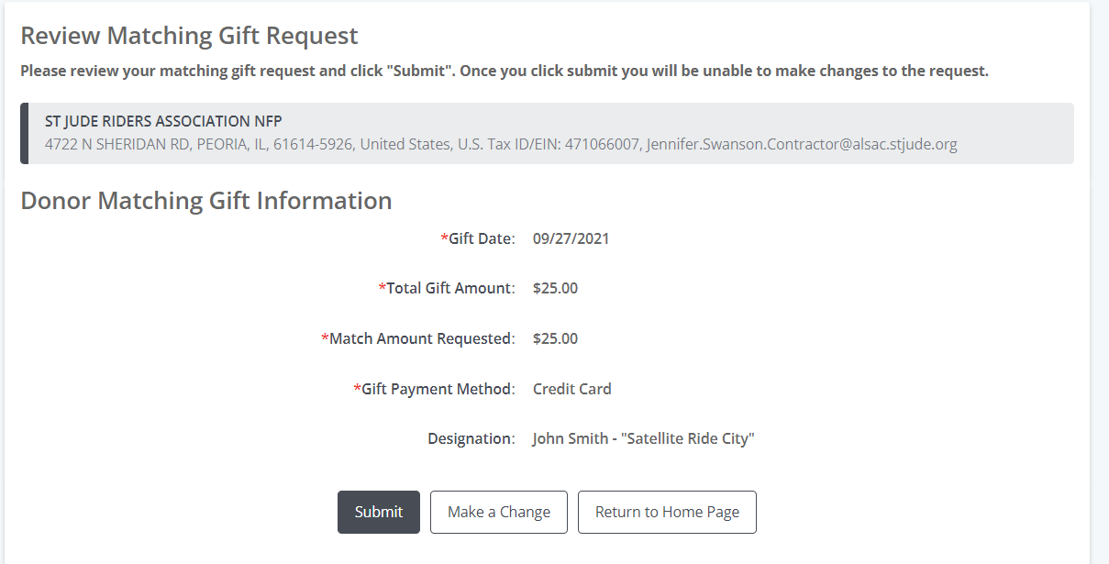

- Click “Email Match Request to Nonprofit” or “Print and Mail Request to Nonprofit”.
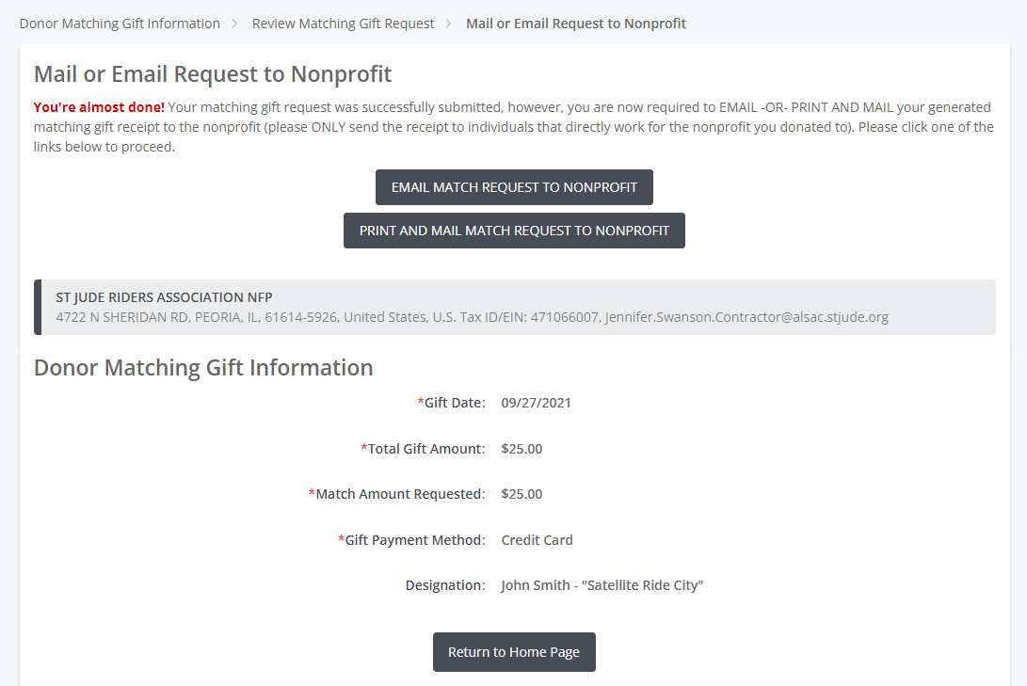

- To email, enter jennifer.swanson.contractor@alsac.stjude.org into the recipient field. Scroll down and click “Preview”. (You do not need to upload any attachments or include additional messages.)
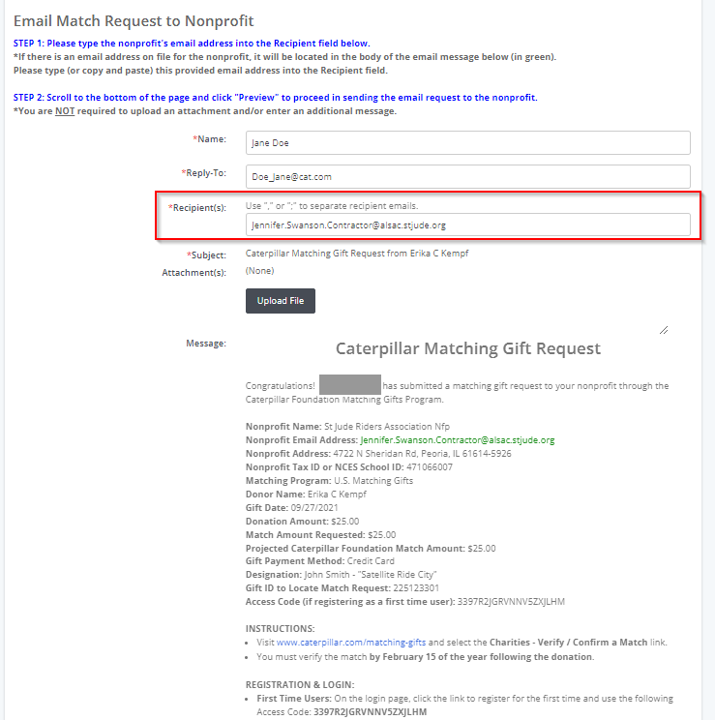

- Scroll down and click “Send”. The process is then complete!
